Robert Hedegaard Andersen December 13, 2018
My Nutritional Game Plan
My Ideal Day of Eating Thursday December 20
Time – What I Ate | Rationale for my food choices and serving sizes
7:30 breakfast  - 4 scrambled eggs with olive oil, salt and pepper  - 1 piece of toast with cheese  - 1 yogurt cup  - 1 glass milk  - 1 glass water  10:30 snack  - Granola bar  - Fruit bar  12:00 lunch  - Sandwich with cheese, mayonnaise, ham, lettuce and honey mustard  - 1 glass water  1:15 snack  - 3 mandarin oranges  4:00 afterschool snack  - Bagel with cheese and ham  - 1 glass of milk  - 1 glass water  6:30 dinner  - Butter chicken with whole grain rice  - Boiled veggies  - Naan bread  - 2 glasses of water | Breakfast  3 – protein, 1 – good fat, 3 – dairy, 1 – grain  1 – fruit  Eggs are a high quality source of protein, very easy to make and they taste great  Chees and milk are very easy sources of dairy  Yogurt is not the best fruit/dairy because of the added sugar, but because the rest of my breakfast is not that high in sugar I thought it was ok to add it.  Snack  1 – grain 1 – fruit  Granola bars are a great healthy carb and gives you required energy  Fruit bars are easy antioxidants, but do contain a lot of sugar  Lunch  1 – grain, 1 – dairy, 1 – protein  Sandwiches contain all food groups, are reasonably healthy  Snack  2 – fruit  I like oranges  Afterschool Snack  2 – grain, 2 – dairy  Bagels are a large grain source and adding the cheese is much better than adding Nutella. I find that I need a large snack afterschool, right before I begin my homework  Dinner  3– protein, 3- grain, 2 – veggies  Chicken is probably one of the best sources of protein  Drinking a lot of water is important

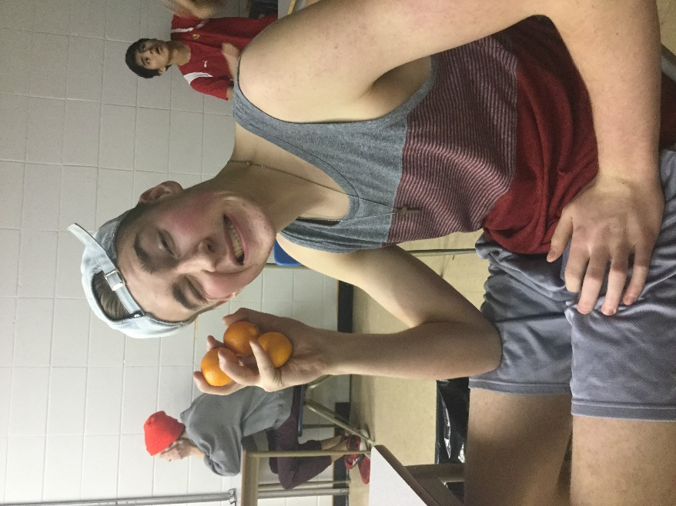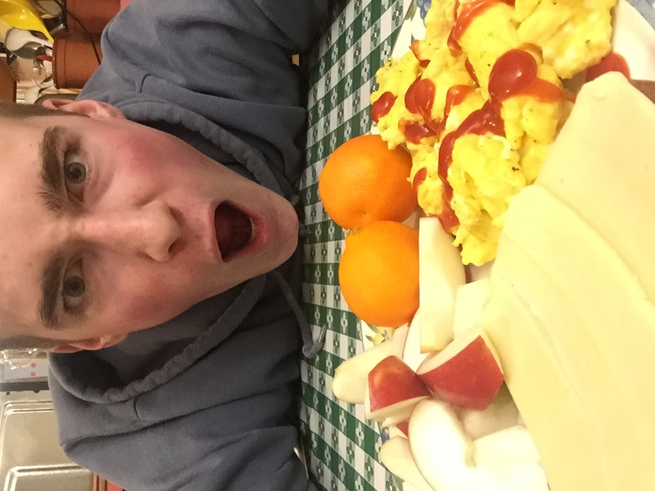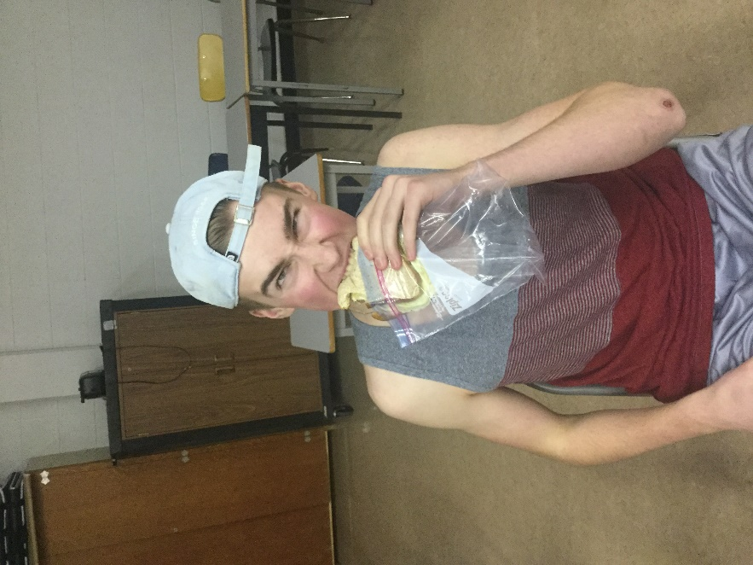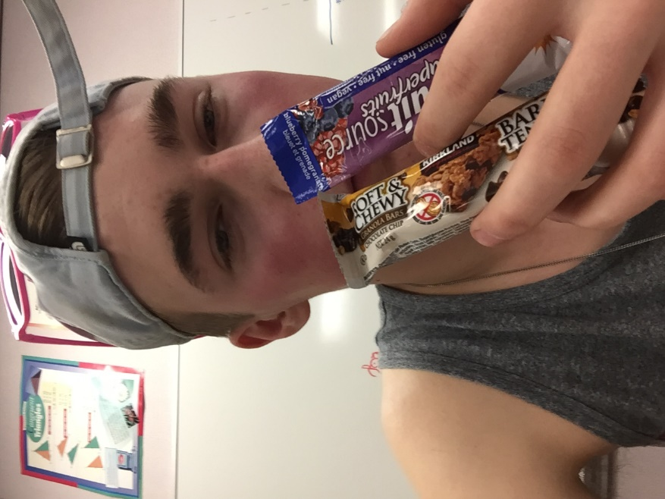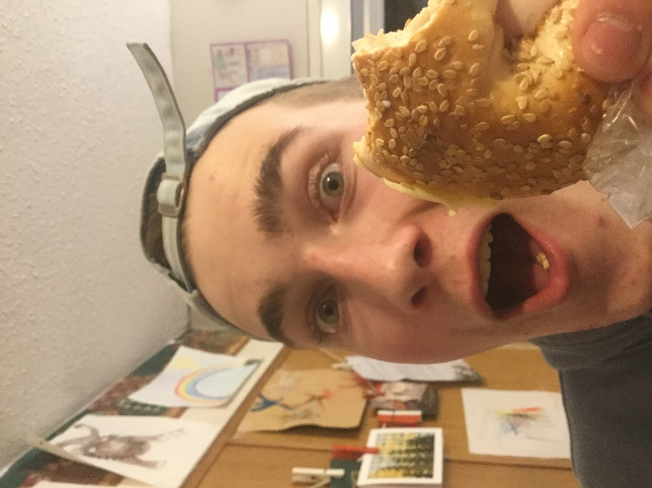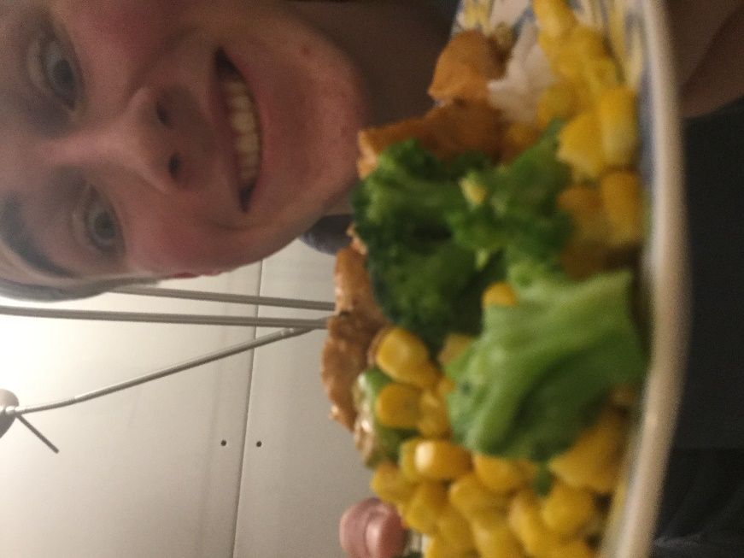
Health and Fitness Baby!!!!
Here are some intense pictures of me enjoying my exciting day of eating healthy. I would like to use this time to credit my mom for making my dinner and my dad for earning money so I can eat food. Personal fitness 12 is the best class at KRSS.

