Fueling for Podium Power

Dana Lis, MMSc. (c), RD, IOC Dipl. Sport Nutrition

Why is nutrition important

• Preparing & fueling your body

• Recovering & repairing your body

• Reducing injury & illness

• Maintaining a body composition

• Achieving peak performance

• Power, strength, speed, agility

• Mental concentration & focus

• Endurance & energy

• Safety

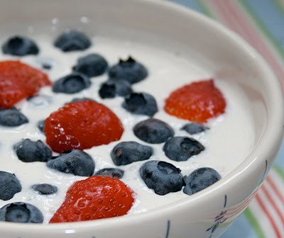

Today…

1. Nutrition Condition

2. Best Bites Macronutrients

3. Fueling for Training

Sport Nutrition Basics

The 4 main nutrients essential for athletes are:

a) Meat, dairy, juice, sugar

b) Carbohydrate, protein, fat, water

c) Bread, fruit, meat, nuts

B

Sport Nutrition Basics

What are the best “types of foods “ to consume for energy during training?

a) Protein

b) Carbohydrates

c) Fat & Carbohydrate B

d) Glucose

HIGH PERFORMANCE
NUTRITION

Protein
Growth, repair and maintenance of body tissues

Carbs
Energy and
Glycogen

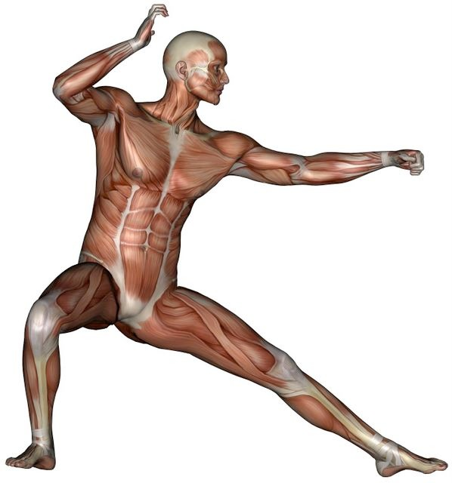

Fats

Fluids
Fuel source and fat tissue

Circulate energy to muscles and brain

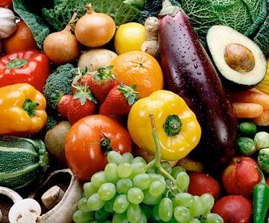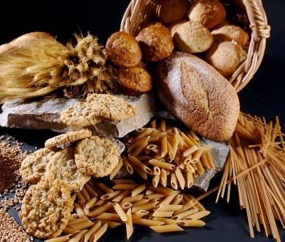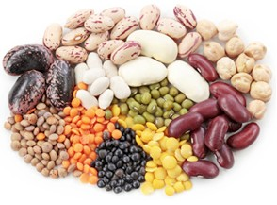Gold level Carbohydrates for
Energy

Best Bites ✔
Cereal, & granola bar, crackers and bread

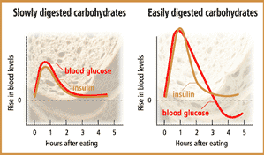Not all carbohydrates created equal

Knowledge Check

Protein is important for growth, maintenance and repair of muscles and tissue. Athletes need to make sure they get enough protein from
these sources:

a) Skippy peanut butter

b) Cheese & hamburgers

c) Fish, chicken, soy, milk

C

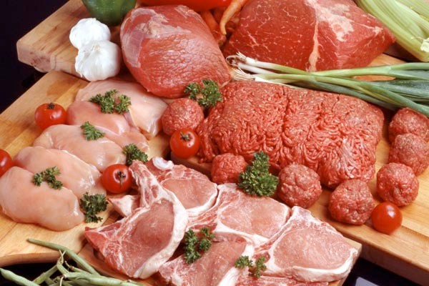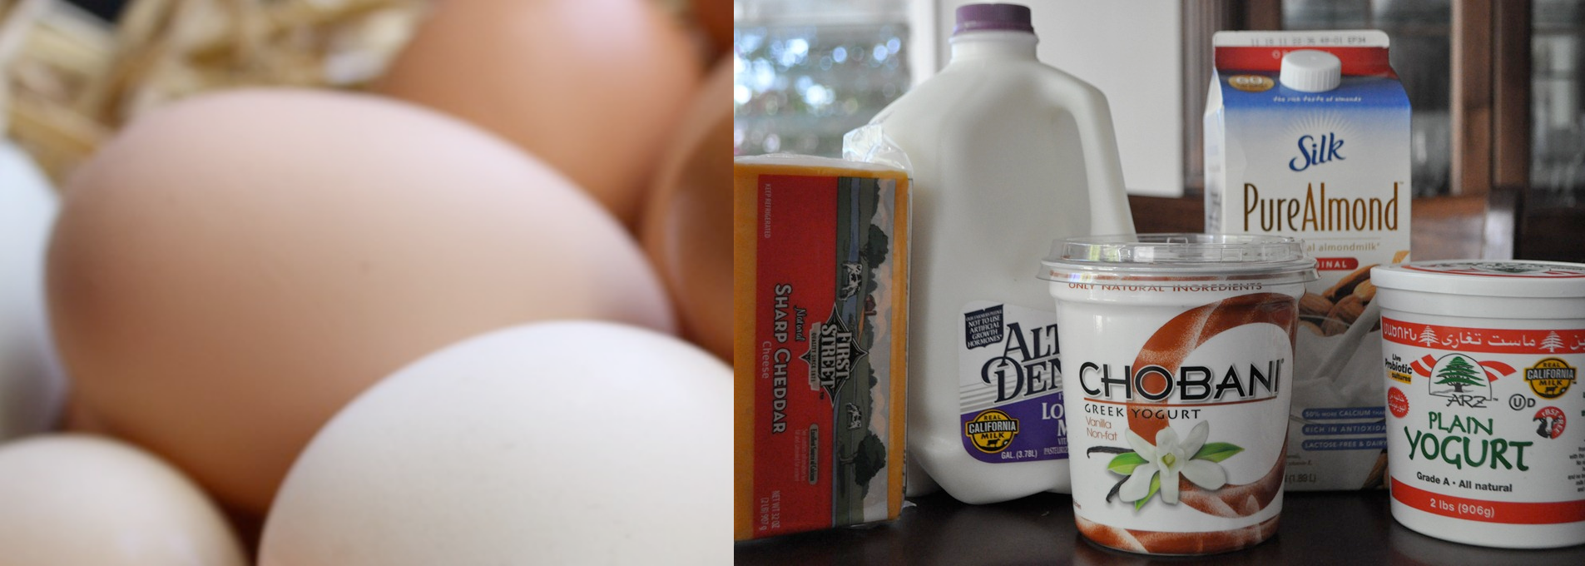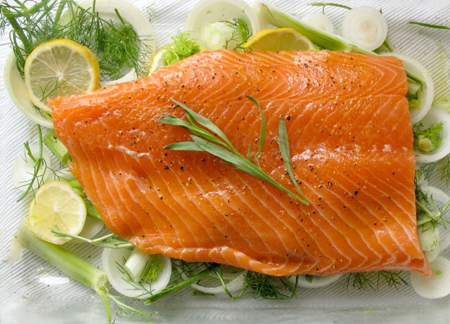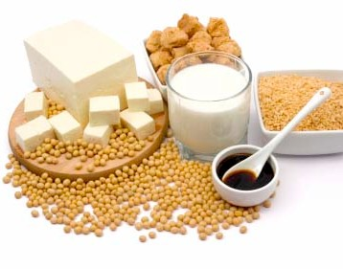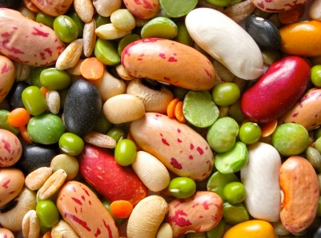Gold level Protein for Growth
& Repair

How much protein do I need?

 Increased needs for growth, recovery, training, adaptation.
 Exact needs for young athletes unknown.
 Varies depending on phase of training.

✔ Do you have protein in each meal?

1.0–1.8 g/kg/day

Knowledge Check

Fats are important for energy and keeping parts of our bodies healthy. The best sources of fats are:

a) Plant fats like olive, nuts, vegetable

b) Fried chicken

c) Bacon

A

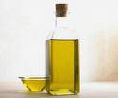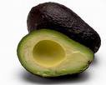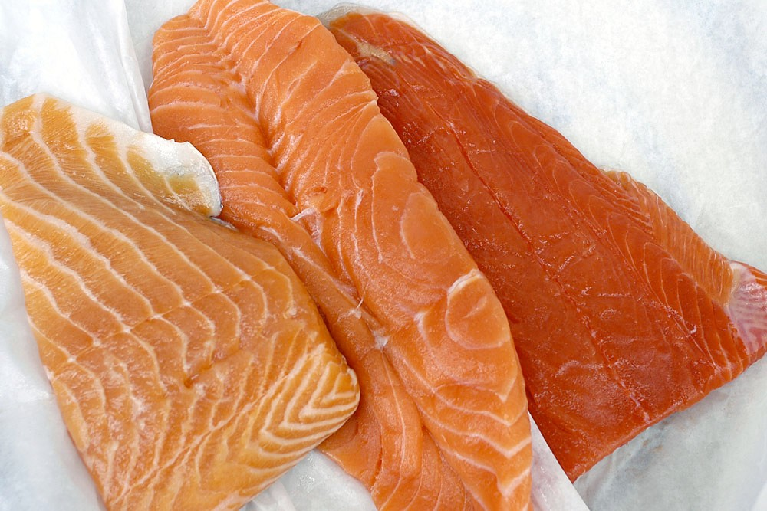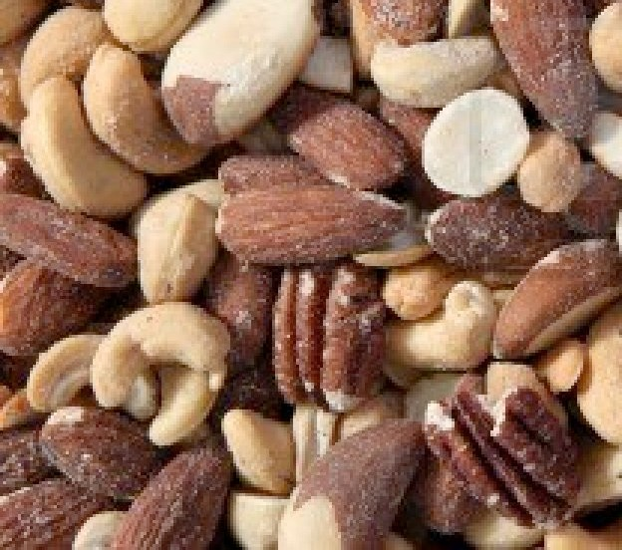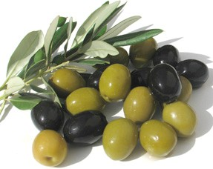Healthy Fats

✔1 healthy fat lunch and dinner.

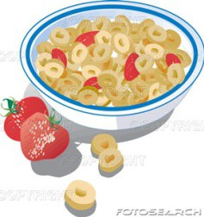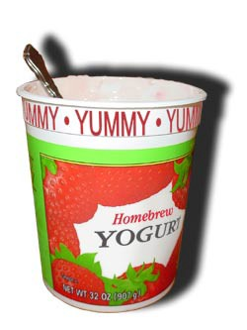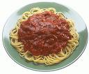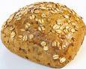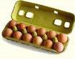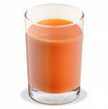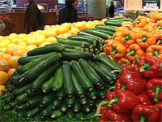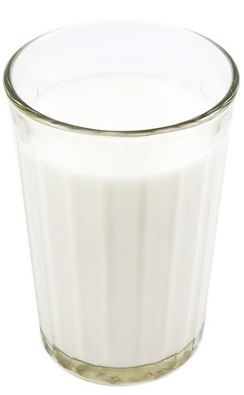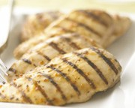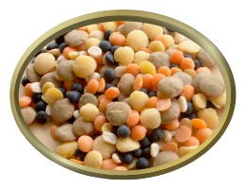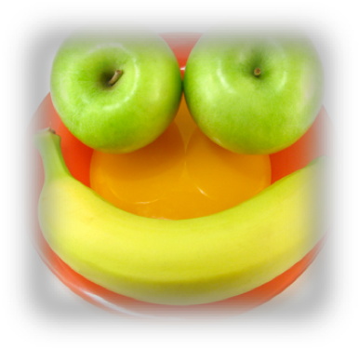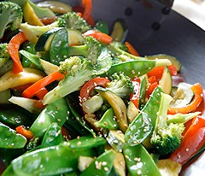

Nutrition: Core Meals

CARBS PROTEIN

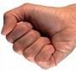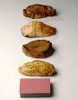
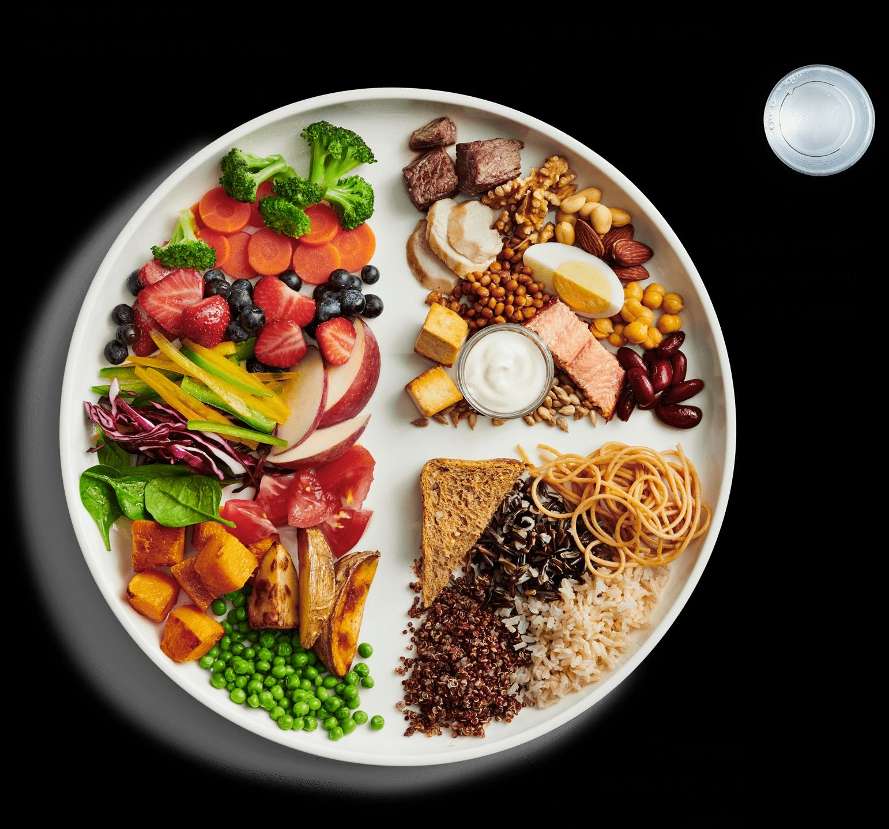

Balance

 | Core Meals(B,L,D)= Canadian Food Guide - FV, BC, MA
 | Snacks = Same Ratios?

1 | serving | of | carbs = 1-2 fists
1 | serving | of | protein = palm
1 | serving | of | fat = tsp or thumb

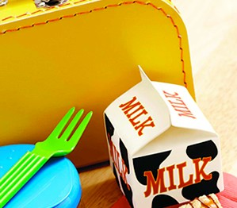

Nutrition Timing

Small and frequent meals =

 More ideal body composition

 Higher metabolic rates

 Improved nutrient intakes

 Better maintenance of muscle

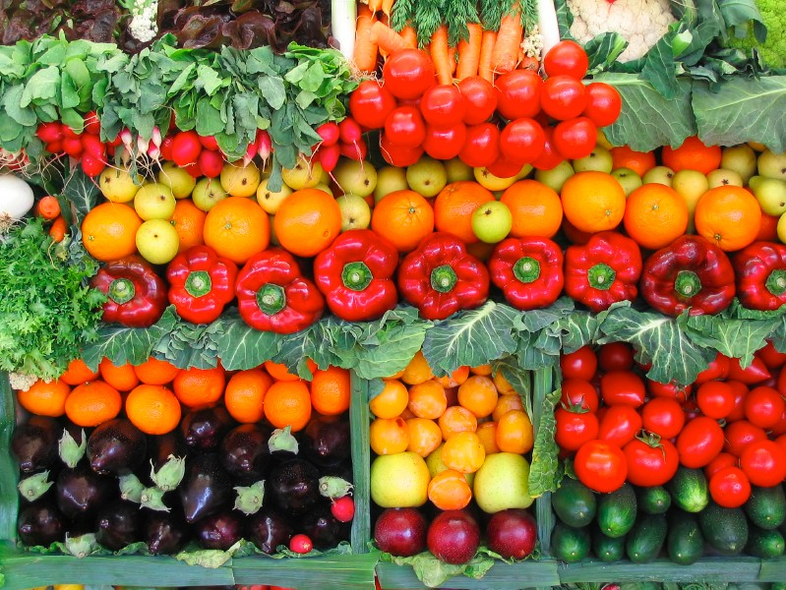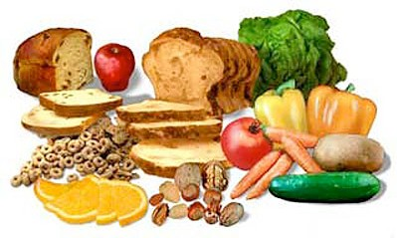

Healthy Weight Management

 Go for nutrient dense foods

 Go for fiber

 Work with RD

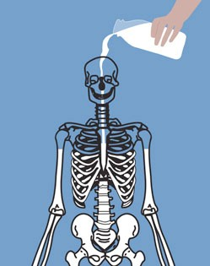

Calcium

 Low calcium intake may be associated with poor bone development and higher stress fracture risk.

 How many servings do you have?

Best Bites ✔
Yogurt and Dairy

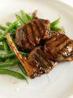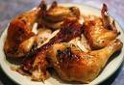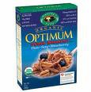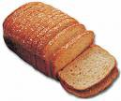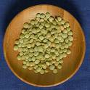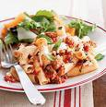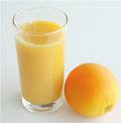

Iron Needs

Iron needed to:
• Transport oxygen
• Produce energy
• Maintain immune system

Higher losses in athletes:
• Inadequate dietary supply
• Increased demands
• Blood loss, foot strike injury
• Heavy sweating

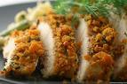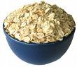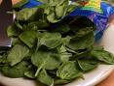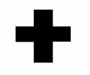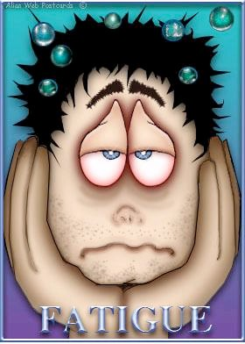

Iron Intake Looks Like…
 Female athletes need more

 Not enough iron: fatigue and weakness, pale skin , rapid heartbeat, irritability, decreased appetite

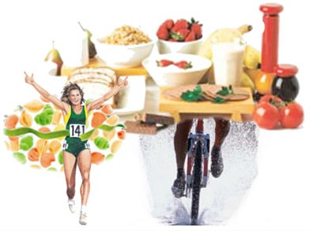

Training Fuels

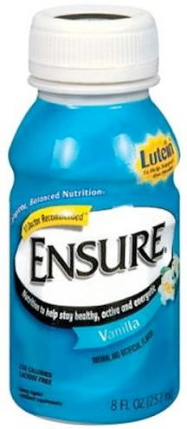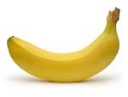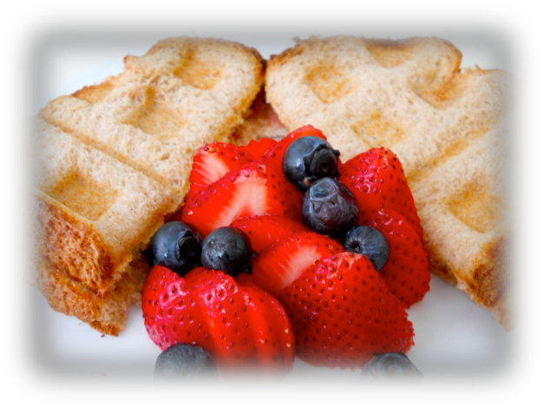

Pre-Exercise

When: 1–4 hours before

What:
• High carbohydrate

• Moderate protein
• Fluids (250-500 ml)
• Low fat

• Low fiber
• Easy to digest

…Keep fueling

Back to back race/comp/training
< 30 min between – liquid CHO
30–2 hrs – easy digest CHO
>2 hrs CHO + Pro (meal or snack)

If race time variable, weather dependant keep sipping sport drink every 15 min.

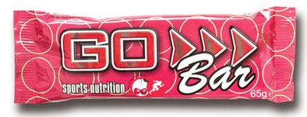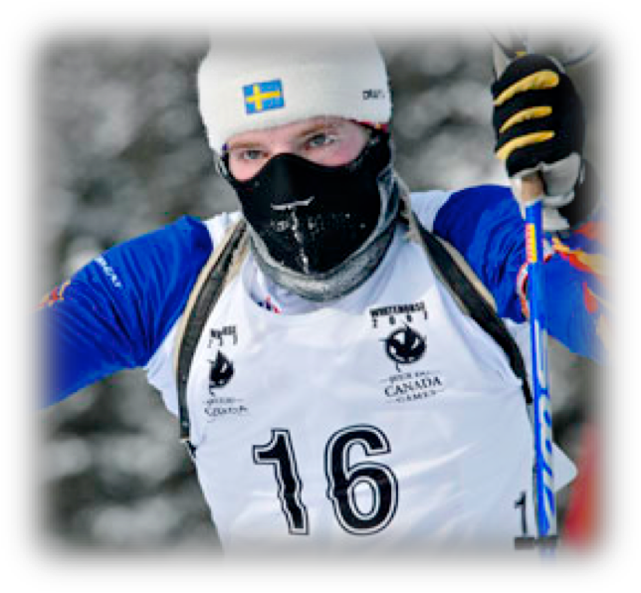

During Exercise

When: during exercise

< 90 min

> 90 min CHO

What: Easy to digest CHO, liquid or solid

Examples:
 Sport drink

 Energy bar
 Banana

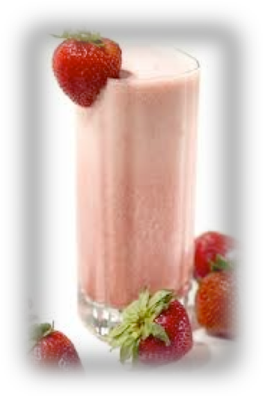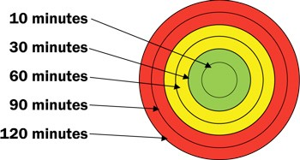

Recovery

When: < 30 min. What:
• High carbohydrate

• Moderate protein (0.25–3 g/kg BW
protein, ~ 15–25 g)

• Fluids

• Low fat

• Easy to digest

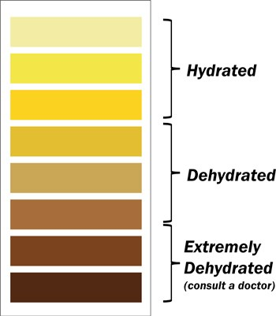

Hydration

 Dehydration decreases performance, especially in hot climates.

 Drink before you are thrisy.

 Water bottle with you all day and drink it.

 Check nutrition record?

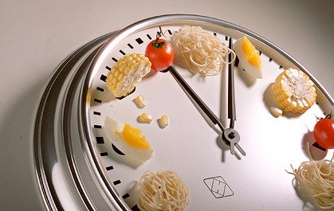

Timing is Key

T.N.T. Training + Nutrition Timeline
TRAINING:
When to fuel up for optimal performance and recovery

7:20- 8:20
12:30 – 2:30

6am 8:30 am 11am 12pm 1pm 2pm 3pm 4pm 5pm 6pm 7pm 8pm

Fluids

Breakfast

Recovery Snack/ Breakfast#2

Lunch
Fluids +
carbs

Recovery Snack (30 min)

Dinner

Evening
Snack

• Eat every 2-3 hours
• Have a high CHO evening snack before bed if training in morning

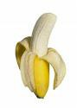

Plan Pack Perform

• Do not rely on fast-food

• Stock your training bag with high CHO foods
& drinks

• Make a list for & go shopping as a family.

Planning: What do you need?

• Before morning training?
– Cereal and juice
– Yogurt and banana
– Crackers and milk

• After morning training?
– Water
– Bagel and peanut butter
– Bag of cereal, milk
• At lunch?

– Bread, meat, veggies, fruit & milk
• After school?
– Baby Carrots/hummus
– Fruit bar or raisins
• After practice?
– Water
– Yogurt or bar, fruit
• Dinner (a real one)
• Bedtime carb snack

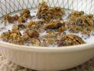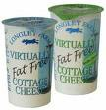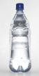

Design Your Post Exercise
Nutrition

 Using list of carb & protein foods in handout

 Design 2 new recovery snacks or meals to meet your individual needs

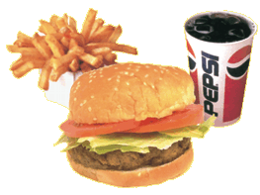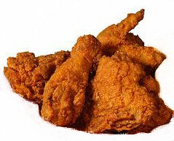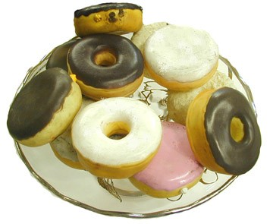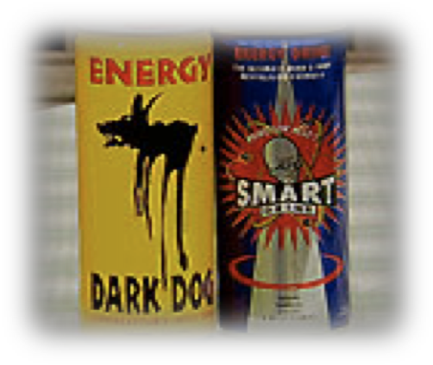

90/10 Rule

Questions?

danalisforrest@gmail.com www.summitsportsnutrition.com

