STKR Secondary – INDIVIDUAL FITNESS PROFILE
Personal Fitness

Last Name: ________________ First Name: _________________
Teacher: ________________

Fitness Area/Test | Pre – Test |  | Mid – Test |  | Post - Test
 | Test Score |  | Test Score |  | Test Score
Agility – Shuttle Run
Cardio End – Beep Test
Power – Vertical Jump
(Jumping Ht. – Standing reach)
Power – Standing Long Jump

Flexibility – Sit and Reach
Mus. Endurance – One Minute Sit Ups
Mus. Endurance – Cadence Pushups
Mus. Strength – Bench Press  Weight options to be used:  45, 65, 95, 115, 135, 155, 185, 205, 225  Weight to touch chest with pad  Must have two spotters – no exceptions! | Wt. Lifted | Reps | Wt. Lifted | Reps | Wt. Lifted | Reps
Your Test: ?? Relevant to goals
Height (cm)
Weight (lbs)

Functional Testing Adapted from the FMS Scoring Sheet in Functional Performance for Sport, pg. 42.
Test | Pre -Test Score -1,2, or 3 | Comment  Pre Test | Post -Test Score -1,2, or 3 | Comment  Post Test
Deep Squat
Hurdle Step
In-Line Lunge
Shoulder Mob.
Straight Leg Raise
Rotary Stability
Seated Rotation
Total out of 21

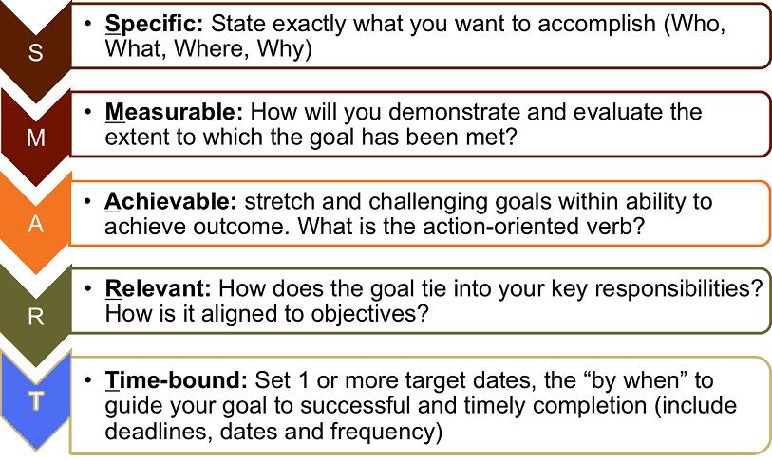
Goal Setting Personal Fitness
Your overall fitness goal(s)(can be broad and long term goals – place for dreaming ) :

What training were you doing before taking this class to move you towards your goal? :

What are you going to go to improve your fitness, over and above participating in this class to the best of your ability?

How are you going to measure your success in achieving your fitness goal(s)? – Create a SMART goal:

