Unit 1 - Homework Sheet #1- Fitness Theory – Chapter 2

Answers for the following questions will be found on pages 8-10 in Fitness Theory & Exercise Physiology.

FITT Guidelines for Aerobic, Strength, Endurance, and Flexibility Exercises
PHYSICAL FITNESS PRINCPLES
 | Aerobic Fitness (Cardio) | Strength | Endurance | Flexibility

F
Frequency

I
Intensity

T
Time

T
Type of Exercise

The Overload Principle-____________________________________________________
________________________________________________________________________________________________________________________________________________________________________________________________________________________
Specificity of Training (pg. 16) – ____________________________________________
_______________________________________________________________________
_______________________________________________________________________
_______________________________________________________________________
Principle of Rebuilding Time – The body needs time to repair and rest between workouts.
Principle of Muscle Balance – One must train both sides of a joint to avoid muscle imbalance.
Loss of Training – Use it or Lose it Principle! When a relatively fit person stops an exercise program, it takes only a few days for his/her fitness level to drop.
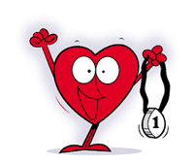
Heart Rate Monitoring

Look to pages #12-13 in the Body Blueprint manual to fill in the blanks below.

How to Take a Heart Rate- Summarize the tips given.

a) ________________________________________________________________
b) ________________________________________________________________
c) ________________________________________________________________
d) ________________________________________________________________
1. ________________________ Heart Rate - heart rate at complete rest – usually 60-85 beats per minute
- best taken right after you wake in the morning
- for our intents and purposes it is taken after lying down for four or five minutes

2.Target Heart Rate – Also called Aerobic Heart Range - Pulse range the heart must work within in order for improvement of cardiovascular fitness to take place.
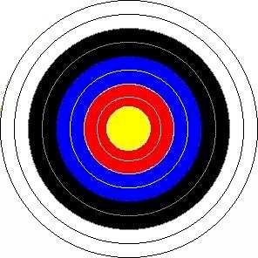

Ideally _____ % to _____ % of your maximum heart rate.

For your age 23 to 29 BPM.

Activity | Heart Rate (10 seconds) Your Guess | Actual Heart Rate (10 seconds)
Sitting
Walking
Jogging
Running
Intervals

How is exercise going to change your body to make it more fit? What changes will occur? (Will need to hunt in the book for this one! )

- ____________________________________________________________
- ____________________________________________________________
- ____________________________________________________________
- ____________________________________________________________

