Homework Sheet #3 - Nutrition- Chapter 8

Answers for the following questions will be found in Chapter #8 in Fitness Theory & Exercise Physiology.

Read through the General Food Guidelines and choose three that you already put into practice and three that you will try to put into practice. (pg. 142-143)

Three guidelines I am already following:
a) __________________________________________________________
b) __________________________________________________________
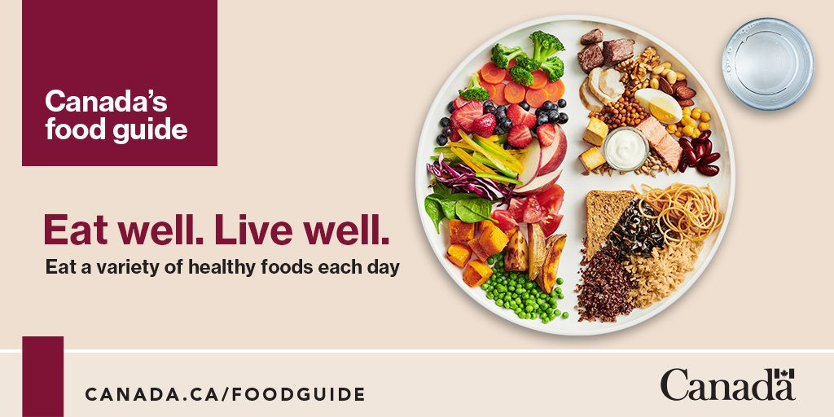
c) __________________________________________________________

Five guidelines I will try to put into practice:
a) __________________________________________________________
b) __________________________________________________________
c) __________________________________________________________
d) __________________________________________________________
e) __________________________________________________________

Vitamins and Minerals (pg. 145)

Minerals are ________________ compounds. List four roles that minerals play in the human body.

- ______________________________________________________________
- ______________________________________________________________
- ______________________________________________________________
- ______________________________________________________________
- ______________________________________________________________

Vitamins are _______________ materials that the body cannot _________________ . List the two roles that vitamins play in the human body.

- _______________________________________________________________
- _______________________________________________________________

Fiber is found in ____________ _______________ such as _______________, ______________________, _________________, and ____________________ . List three roles fiber plays in the human body.
- _____________________________________________________________
- _____________________________________________________________
- _____________________________________________________________

(Pg. 146-148) | Carbohydrates | Proteins | Fats
% of total daily calories
Kcal per gram
Time for digestion
Role in Human Body
Other interesting tidbits!
More about Fats – the Good, the Bad, and the Ugly
(pg. 148-149)
Good Fats
_________________ fats – most often liquids at room temperature.
Examples
a) ___________________ fats – lowers low density lipids, or LDLs, in the blood.
May also prevent certain ___________________ .

Examples of these fats: ___________________
___________________
___________________
__________________

b) __________________________________ Oils (or ___________________ fatty acids) – are great for your ___________________ and fight _____________________ _________________. These oils also lower triglycerides and make the blood in blood vessels less likely to form clots.

Examples of these fats: ______________________ ______________________
______________________ ______________________
______________________ ______________________

Bad Fats

________________________ fats – likely to be associated with deposits of cholesterol, causing narrowing and hardening of the arteries.

Examples of these fats: ______________________ ______________________
______________________ ______________________
___________________________ fats – (sometimes called trans fatty acids )liquid vegetable oils that have had hydrogen atoms injected into them to make them harden to be used for items such as margarine. These fats increase the levels of LDL in the bloodstream and should be avoided!
Places these are found: ________________________ ________________________
_________________________ ________________________
_________________________ ________________________

The Ugly Reality – Too many good or bad fats are to be avoided. No more than _________ of your daily calories should come from fat. To figure this out you must become a label reader for everything you eat!
Another friendly reminder – excess calories consumed that are either carbohydrates or proteins will be converted to fat. So even though that new ice cream you are eating has half the fat of regular ice cream, this doesn’t mean you should have a triple helping!

Water (pg. 149)
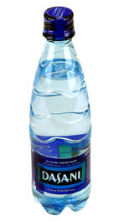

Daily intake for the average adult is approximately ____________ liters.

Water must be replaced at the level of _________________ for each pound of body weight lost in any exercise or training session.

Water’s Functions in the Body

a) ______________________________________________________________
b) ______________________________________________________________
c) ______________________________________________________________
d) ______________________________________________________________
Do not trust thirst as an indicator of hydration during exercise. Be proactive in your hydration needs.

Before Exercising – in the 2 to 3 hours before training consume ______________ cups of liquid.

- 10 to 15 minutes before exercise consume an additional __________ cup(s) of liquid.

During Exercise – consume a _________________ every ____________ minutes

After Exercise – drink fluids until _________________ is pale.

Avoid caffeinated beverages (coffee, pop), or alcohol as these do not effectively hydrate.

Just before and during exercise avoid a drink with higher than 7% carbohydrate solution. Beverages with a higher than 7% carbohydrate solutions will have to be digested by the body and will slow its absorption rate by thirsty cells! Carbonated beverages should also be avoided, as they will often cause bloating and gastric distention.

Water is inexpensive and, with the exception of activities lasting over 60 minutes in length, it is the ideal fluid replacement for the body. Don’t get caught up in the hype of the Gatorade propaganda machine.

