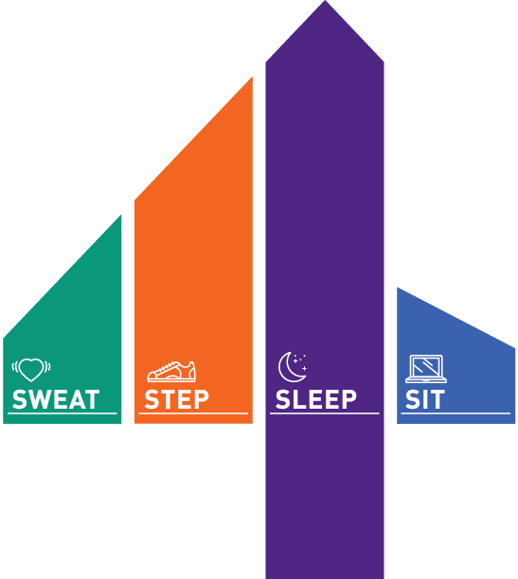Name: _______________________________
 | SWEAT  moderate to vigorous physical activity |  | STEP  light walking/activity | SLEEP  hours per night | Sit/Screen Time  hours per day
EXAMPLE | Nike Training App | 30 minutes | -Walked the dog for 30 minutes  -Yard work with family for 60 minutes  -Hike in the trails while practicing social distancing 2 hours | 8.5 hours | 2 hours of school work/screen time during the day to complete assignments and meet with teachers
 | Reflection on how the work-out went: how did you feel before, during after? Effects of exercise physically, mentally, emotionally.
Monday
Tuesday
Wednesday
Thursday
Friday

