April 6- 10 PANDEMIC PE Course: PE 8/9

Big Ideas: Daily participation in different types of physical activity influences our physical literacy and personal health and fitness goals. Lifelong participation in physical activity has many benefits and is an essential part of a healthy lifestyle.

I am sure that you have been doing lots of sitting and watching of different media devices. Let’s put those phones and ipads to good use and get active! Download the NTC or Nike Training Club app, follow my instructions on the Youtube video that I recorded (https://www.youtube.com/watch?v=j72XmVdNzgU) to locate the correct workouts, and get ready to get jacked!

Equipment Needed: Some space, a backpack filled with 15 lbs. of books, a sturdy chair, and some enthusiasm. The workouts from start to finish will take approximately 20 minutes

Warm up – Do the following exercises across your living room- Our regular class warm up that should take approximately 3 minutes
2X each
High knees, bum kicks, skipping, high knees skipping, squats, shuffles, crossovers, lunges, high leg kicks, shoulder rolls, inchworms, anything else you find is tight.

Do not have an ipad? Complete the exercises listed below after the warm up above.
Have a digital device? Follow the app as the items below are just a repeat of those exercises (and maybe add in one arm rows for those using the app – no pull exercises may lead to muscle imbalance!)

Day #1 - Monday April 6 Day #2 - Wednesday Day #3- Friday, April 10
Start up – Benchmark- Go through 3 times | Drill Essentials – Workout 2- through 3 times | Basic Burner – Workout 3  Through 3 times
Jumping Jacks - 20 | Reverses Lunges – 1:00 | Imaginary skipping -:40
Bodyweight Squats - 15 | Bodyweight Squats- 1:00 | Modified pushups - :30
Modified (Knee) push up - 10 | Modified pushups - :30 | Bodyweight Squats- 1:00
Lateral Lunges – 10 each side | Lateral lunges: 1:00 | Dead Bugs: 40
One Arm Row with backpack- 10 each arm | One Arm Row with backpack- :30 seconds each arm | Reverse Lunges: 40
Front Plank- 20 seconds | Airplanes- L Leg – 1:00 | High Plank (on hands push up position) :40
Side Planks- 20 seconds | Airplanes – R-Leg – 1:00 | High Side Plank : 20 each side
Glut Bridge – 20 seconds per leg | Dead Bugs: 30 | One Arm Row backpack- :30 seconds each arm
 | Front Plank – :20 | Marching Glut Bridge: :40
 | Side Plank – :20 each side
 | Glut Bridge - :20 each leg

How do I get marked for this?

This is all new so there may be some alterations to this plan but here is what I am thinking right now.
The minimum basic requirement is that you complete these three workouts in the first week along with two other activities that are cardiovascular in nature that last at least 20 minutes. Friday you will send me an email to tkuc@sd57 with the subject line: Your Name Self Evaluation.

In the email you will write down what you did each day of the week for activity, and any barriers, suggestions, comments that you would like to include.

You could also include a picture of you working out and I will add it to the website! Be sure you have your parent/guardian’s permission to have the picture posted.
For example :
Monday, April 6 | App Workout – 11:00  30 minutes  Bike Ride- 3:00  1 hr.? | Seemed too easy so I did a second time.  Went for bike ride- don’t worry I social distanced!
Tuesday, April 7 | Cleaned the house – 1:00 minutes (I give permission to use the picture below)  Dog Walk - :30 | The vacuuming was a cardio workout!  Have included picture of my dog- he gives permission as well to use his picture.)
Wednesday, April 8 | App Workout – 11:00  30 minutes  Mobility Workout from Nike App – Fresh on the Circuit – 11:30 - 15 minutes | Great App Mr. Kuc – you really are the best (just checking if you are reading this. ;))
Thursday, April 9 | Did a HITT workout I found on the internet – was from Fitness Blender – At Home HIIT Workout– 11:00  18 minutes | I like Kelly and Dan- chest was slightly sore from yesterday so I modified chest exercises
Friday, April 10 | App Workout – 11:00  30 minutes | Will do some exercise on the weekend. Have been doing the workouts with my sister and it is helping pass the time.
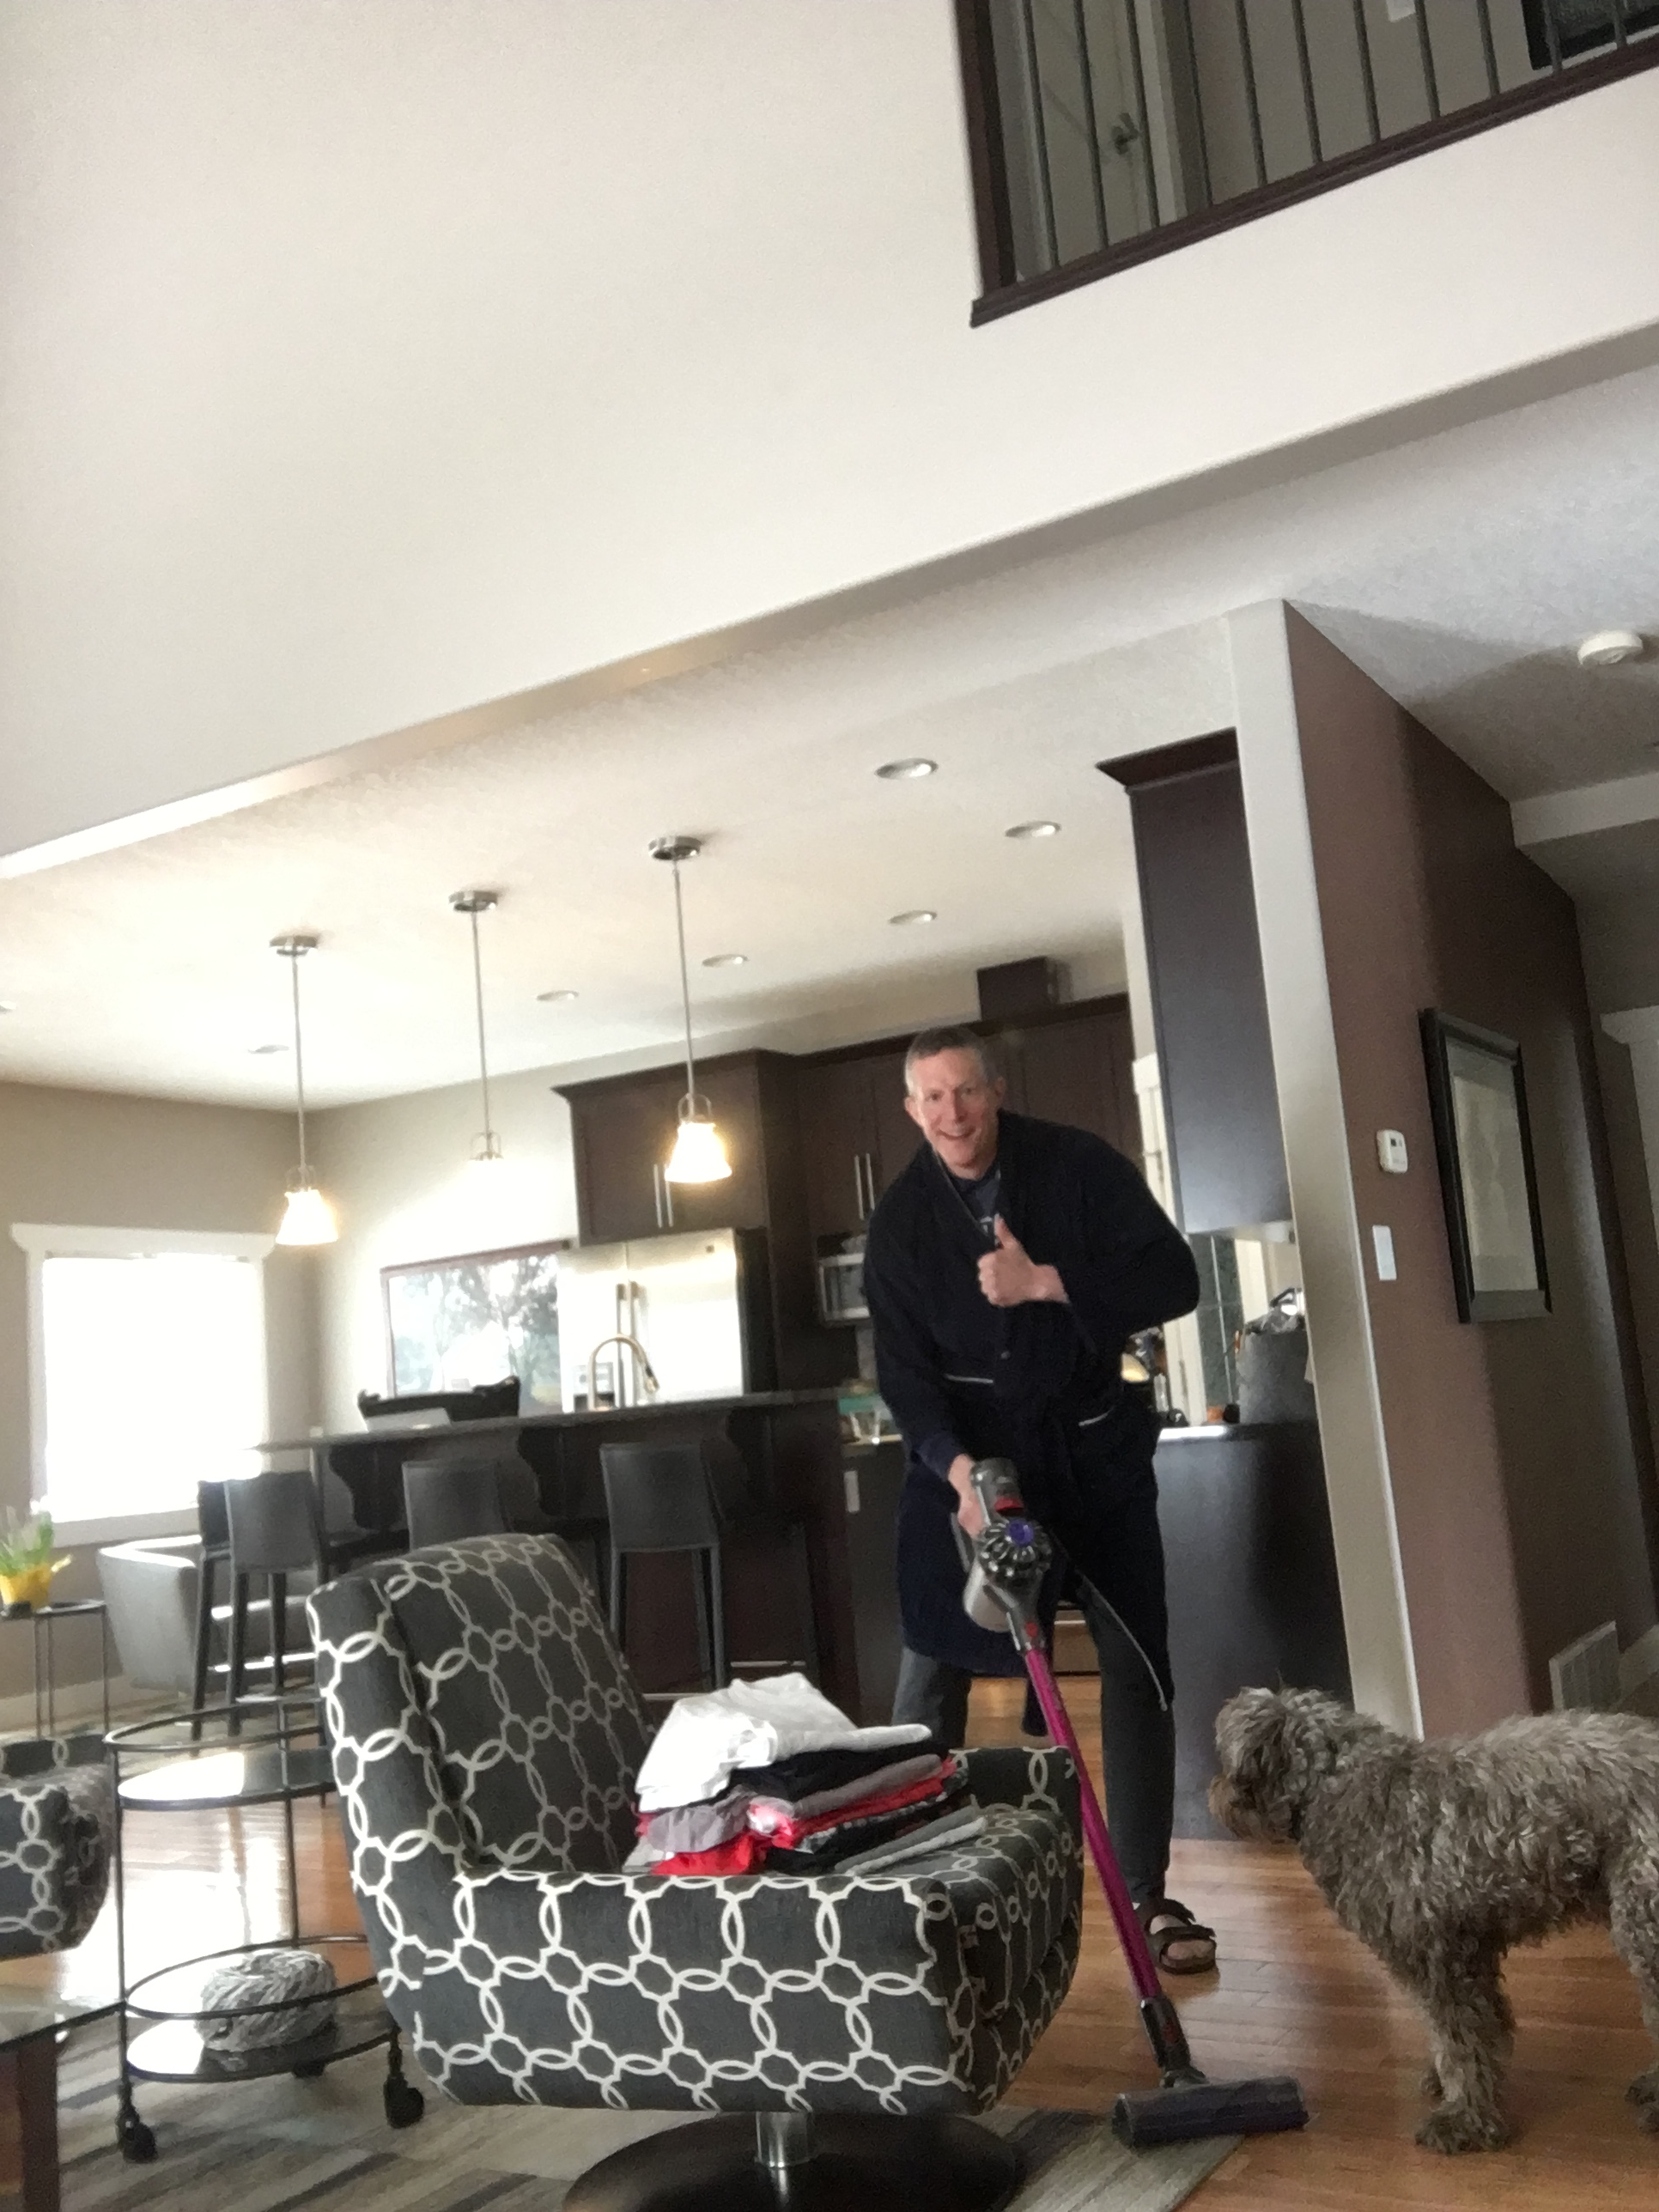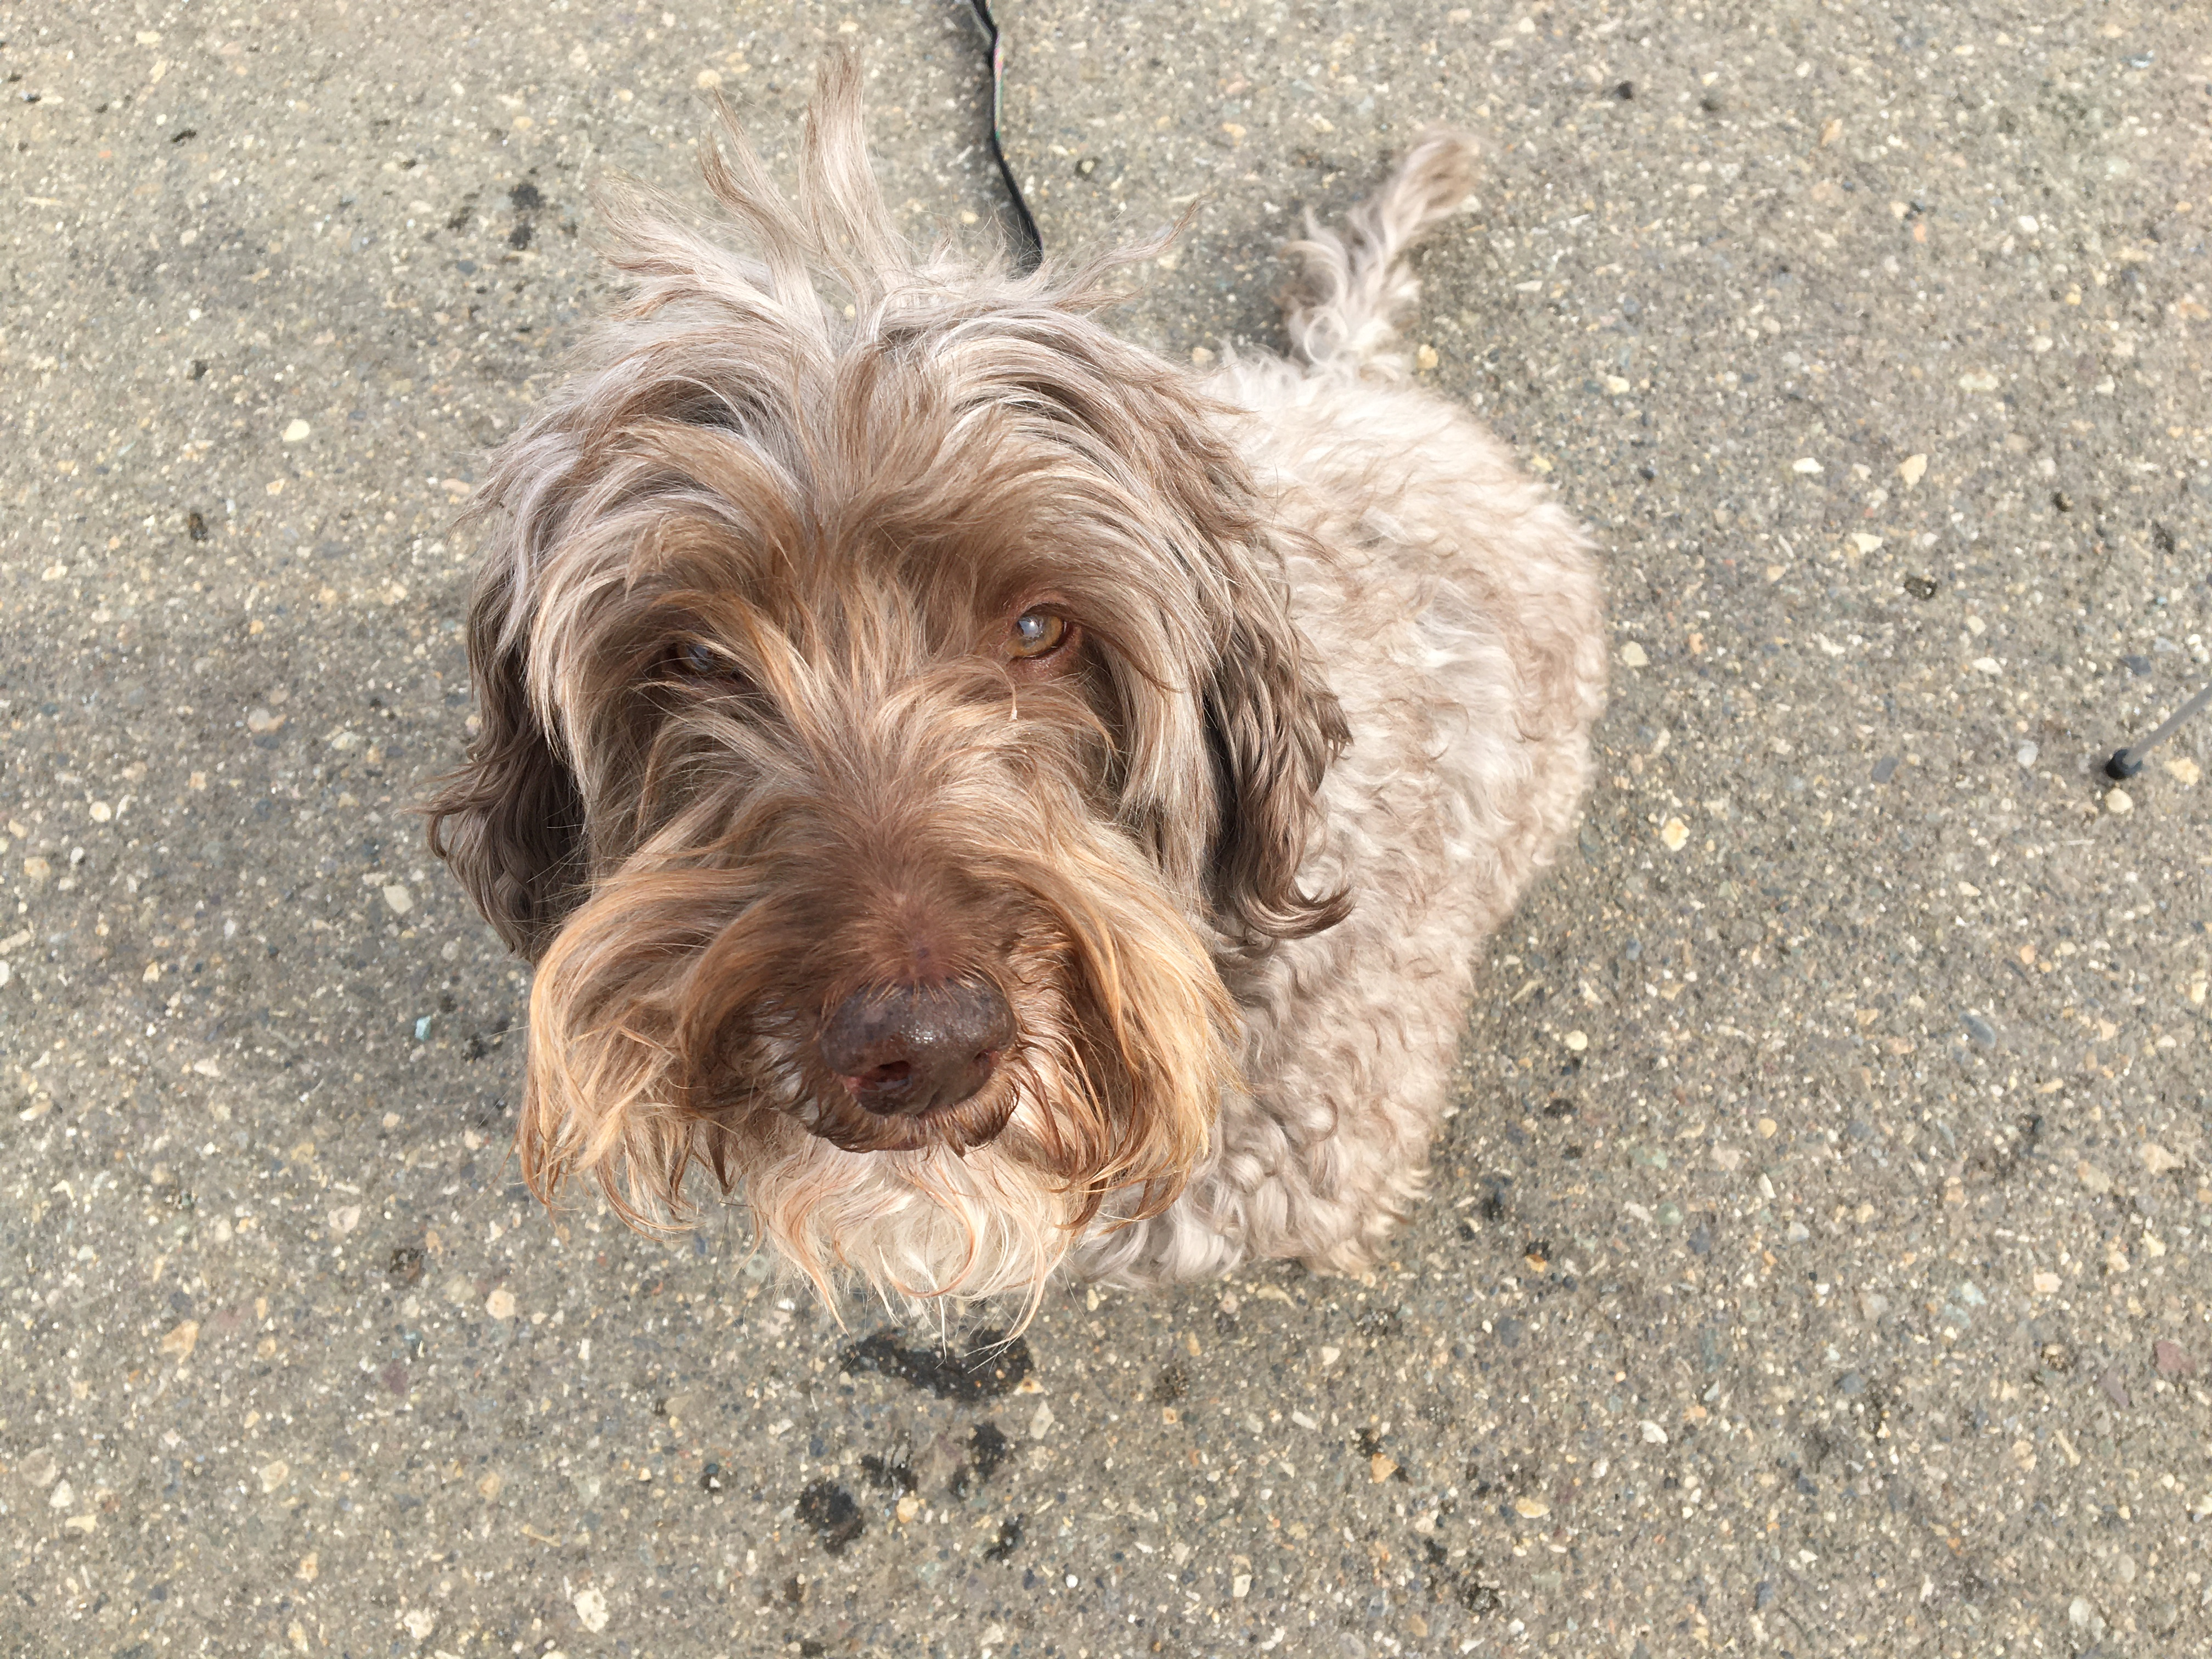
My walking buddy!

Who says housework can’t be fun?

