Name: ___________________________________________________________________________
Pandemic PHE
B I N G O
Ultimate Edition! (June 15-21, 2020)

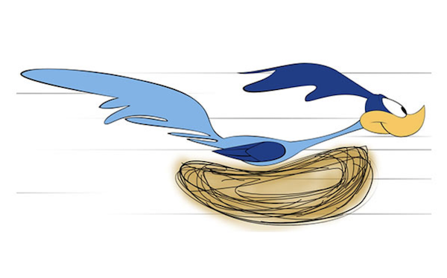
After you complete a healthy option below, write the date on top of the square. Every line completed equals an entry in a draw for some exciting limited-edition Kelly Road SWAG or other prizes TBA!
Send in whatever you have completed by Sunday, June 21st. BE SURE TO COMPLETE QUESTIONS ON PAGE 2.
Engaged in water sport- swimming, jet ski, canoeing, kayaking, SUP, etc. | Chopped wood and/or built a campfire | Played a game in the backyard – horseshoes, bocce, Spikeball, etc. | Jumped on trampoline in the yard for at least 10 minutes | Hiked for 30 minutes or ran the cut-banks
Did karaoke or sang songs around the campfire | Rode mountain or dirt bike on trails | Went for X-country run for more than 20 minutes | Saw a wild animal (sure, squirrels count) | Watched the sunset or sunrise
Went geocaching or scootered/biked around neighborhood | Used bike or feet for transportation instead of getting a ride in car | FREE SPACE  list activity not on card that brings you joy ___________ | Stayed up after midnight playing cards or board games with a family member | Walked to get an ice cream, slurpee, or other frozen treat
Watched a movie at the drive-in or set up my own “drive-in movie theatre” and watched a movie | Spent 30 minutes or more at the skate park | Completed some sort of strength workout (PE teachers find this fun!) | Played a game in the backyard -horseshoes, bocce, Spikeball, etc. | Engaged in water sports -swimming, jet ski, canoeing, kayaking, SUP, etc.
Danced for 15 minutes or more | Went fishing or golfing | Did something active with someone in my family | Helped family by completing a chore - feeling of accomplishment is fun | Went camping, even if only in the backyard

Final Reflection Questions for the Semester
- One of the goals of PHE is to help you find some games/activities that you will continue to do after your time at school is complete. Which activities did you enjoy the most during this pandemic PHE?

- Which of the following guidelines did you find the hardest to meet? Explain your answer.
Sweat | Step | Sleep | Sit
- An accumulation of at least 60 minutes per day of moderate to vigorous physical activity involving a variety of aerobic activities. Vigorous physical activities, and muscle and bone strengthening activities should each be incorporated at least 3 days per week; | Several hours of a variety of structured and unstructured light physical activities; | Uninterrupted 8 to 10 hours per night for those aged14–17 years, with consistent bed and wake-up times; | No more than 2 hours per day of recreational screen time; Limited sitting for extended periods.

3. How do you feel your fitness has changed throughout your Pandemic PHE experience?

4. How are you going to continue to stay active throughout the summer? Outline your plan to come back to school in September in the best shape of your life!

