Name: ___________________________________________________________________________
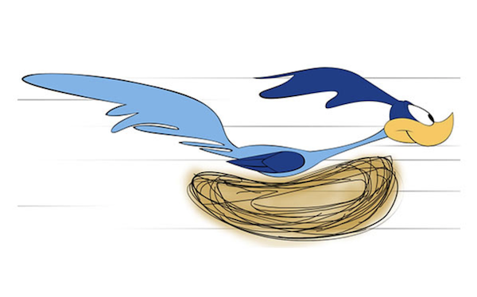
Pandemic PF
B I N G O
After you complete a healthy option below, write the date on top of the square. Every line completed equals an entry in a draw for some exciting limited edition Kelly Road SWAG or other prizes TBA!
Looking for a bonus entry? Send us a picture of you completing one of these squares for another chance at winning.
Send in whatever you have completed by Friday, June 19. PLEASE BE SURE TO FILL IN THE REFLECTION QUESTIONS.
Completed workout on the Nike App | Did not have candy, pop, or an energy drink for 24 hours in a row | Did something active with someone in my family | No social media for 24 hours (Instagram, Tik Toc, etc.) | Completed the strength workout I created for this class or one off any app
Completed workout from any app other than the Nike App | Went for hike for more than 30 minutes | Did active chores around house or cabin for more than 30 minutes | Went for run for more than 20 minutes | Used electronics for less than 2 hours in one day
Used electronics for less than 2 hours in one day | Completed the strength workout I created for this class | Slept for 8 hours or more in one night | Completed workout on the Nike App | Did a socially-distanced activity with a friend other than a member of my family
Briskly walked (or jogged) with dog or friend (sorry cat lovers!) | Did a socially-distanced activity with a friend other than a member of my family | Completed workout from any app other than the Nike App | Went for Bike Ride/Scooter/ Skateboard for more than 30 minutes | Did not vape or use tobacco products for 48 hours in a row
Completed the strength workout I created for this class | Went for Bike Ride/Scooter/ Skateboard for 30 minutes | Did something active with someone in my family | Went to work for more than 2 hours | Ate at least three servings of fruits and vegetables in one day

Final Reflection Questions for the Semester
- One of the goals of PHE is to help you find some games/activities that you will continue to do after your time at school is complete. Which activities did you enjoy the most during this pandemic PHE?

- Which of the following guidelines did you find the hardest to meet? Explain your answer.
Sweat | Step | Sleep | Sit
- An accumulation of at least 60 minutes per day of moderate to vigorous physical activity involving a variety of aerobic activities. Vigorous physical activities, and muscle and bone strengthening activities should each be incorporated at least 3 days per week; | Several hours of a variety of structured and unstructured light physical activities; | Uninterrupted 8 to 10 hours per night for those aged14–17 years, with consistent bed and wake-up times; | No more than 2 hours per day of recreational screen time; Limited sitting for extended periods.

3. How do you feel your fitness has changed throughout your Pandemic PHE experience?

4. How are you going to continue to stay active throughout the summer? Outline your plan to come back to school in September in the best shape of your life!

